Project Design Document

Team name: ITmyRIT

Team members: Breka Mislav, Longin Karlo, Obsivac Marko

Wireframes

Main Menu

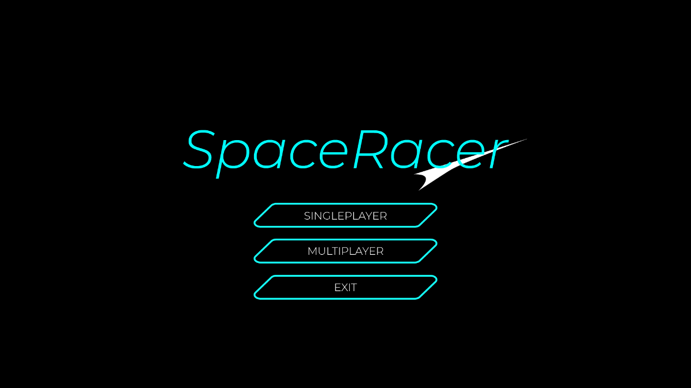

Gameplay (Will be improved)

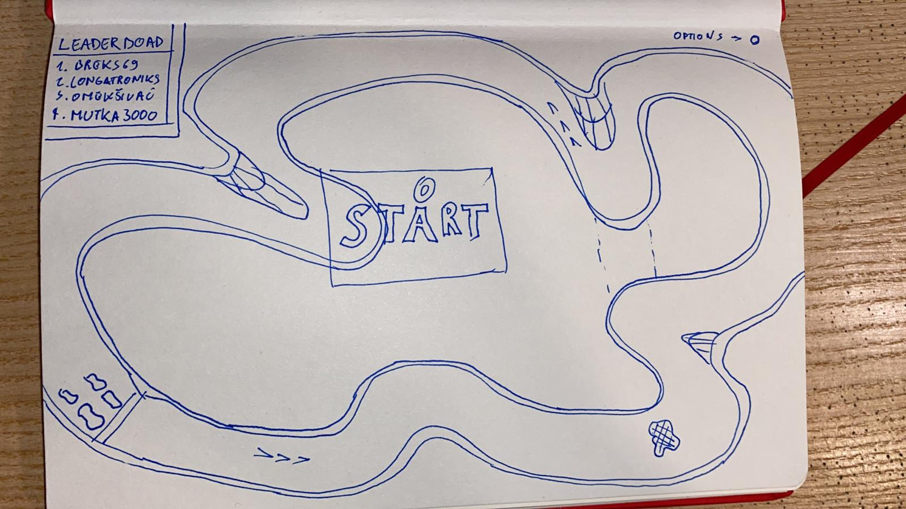

|  |  |  |  |
| --- | --- | --- | --- |
| WEEK | DATE | TASK | DESCRIPTION |
| 6. | 01/03/2021 | GitHub | Creating Organization, Repositories |
| Document Design | Homework |
| 7. | 08/03/2021 | Assets Design | Map, Car icons |
| Menu | Main Menu |
| 8. | 15/03/2021 | Physics | Movement, Collisions |
| 9. | 22/03/2021 | Functionality | Controls |
| 10. | 29/03/2021 | Menu | Other Menus, Options |
| 11. | 05/04/2021 | Extra-functionality | Trails, Coins, Map-Generator |
| Project Day - Design Review  Project Day - Code Review | | | |
| 12. | 12/04/2021 | Multiplayer | TBA |
| 13. | 19/04/2021 | Chat |
| 14. | 26/04/2021 | Final touches | TBA |
| Project Day – Interoperability Testing | | | |

Schedule